**23CSE111**

**OBJECT ORIENTED PROGRAMMING**

**LAB REPORT**



**Department of Computer Science Engineering**   **Amrita School of Computing**

**Amrita Vishwa Vidyapeetham, Amaravati Campus**

**Name: N.chaitanya**

**manikanta**

**Roll No: 24233**

|  |  |  |  |  |
| --- | --- | --- | --- | --- |
| **S.NO** | **Experiment** | **Page No** | **Remarks** | **Signature** |
| **1** | **Installation Process of JDK** | **3-4** |  |  |
| **2** | **Simple java program for printing basic details of student** | **5** |  |  |
|  |  |  |  |  |
|  |  |  |  |  |

**INDEX**

# WEEK-1

1. AIM:

**Process of Installing JDK (Java Development Kit)**

**Installing JDK (Java Development Kit):**

* 1. **Download JDK:**
* Go to the Oracle JDK download page in google and click on JDK-21 version which is Long term support (LTS) version.
* Click the download link as your operating system (Windows, macOS, or Linux).
  1. **Install JDK:**
* Once downloaded, run the installer.
* Follow the given instructions and keep clicking "Next" until it is done.
  1. **Set Environment Variables (Windows):**
* Open file explorer, then right click on This PC next select on properties then it will take you to the settings app then click on advanced system settings and then click on **Environment Variables**.
* Click on path and new under **System Variables**:

**Variable value:** The folder address where JDK is installed (like

C:\Program Files\Java\jdk-21\bin)

* Find Path under **System Variables**, click **New**, and add the path of the jdk-21(C:\Program Files\Java\jdk-21\bin)

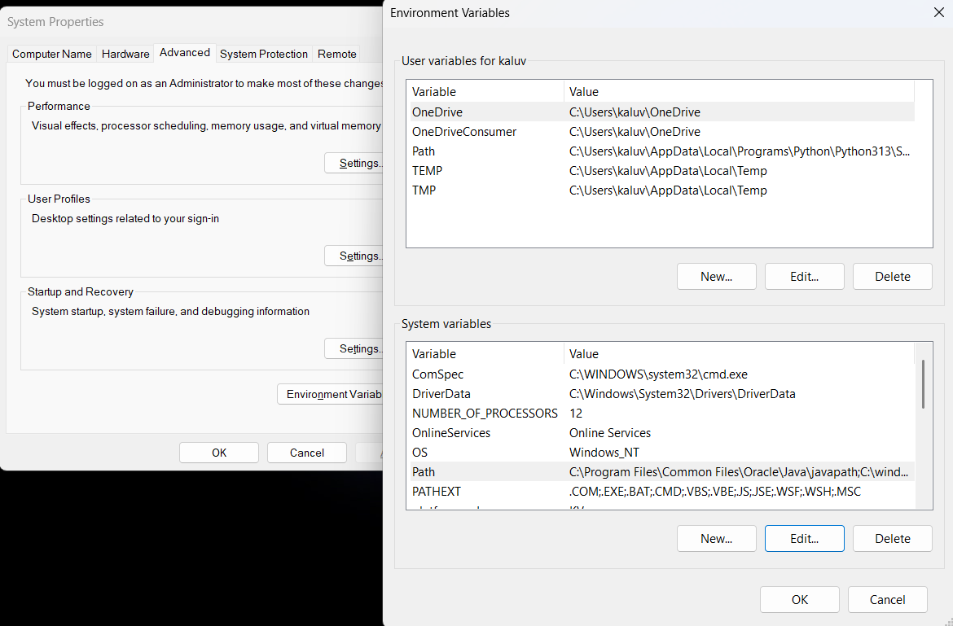

**Checking JDK Version: -**

* 1. **Open Command Prompt:**
* Presswin+R, typecmd, and press Enter.
  1. **Check Version:**
* Type java -version and press Enter.
* Type javac --version and press Enter.

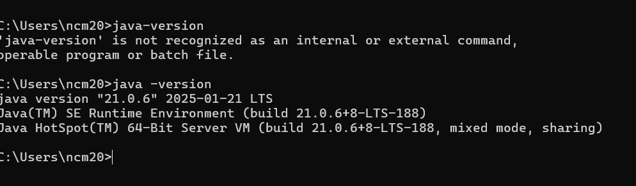

1. AIM:

**Simple Java Program for printing Name, Class, Roll No, of a Student**

Write your code in Notepad and execute it in cmd prompt

**CODE: -**

class Main

{

public static void main(String[] args)

{

System.out.println("Name:N.chaitanya manikanta");

System.out.println("Class:CSE-C");

System.out.println("Roll No:24233");

}

}

**Output: -**

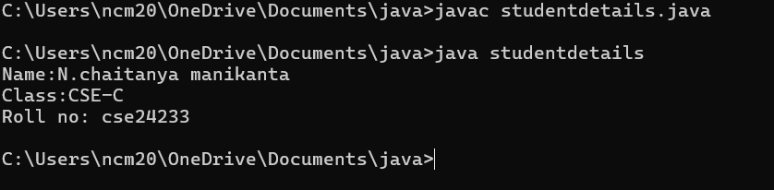

|  |  |  |
| --- | --- | --- |
| 1 | Syntax error | Semicolon added |
| 2 | Runtime error | Copied correct path |
| 3 | Name error | rectified |

WEEK-2

1. AIM:

**Simple Java Program for finding simple interest by taking input from**

**User**

**Code:**

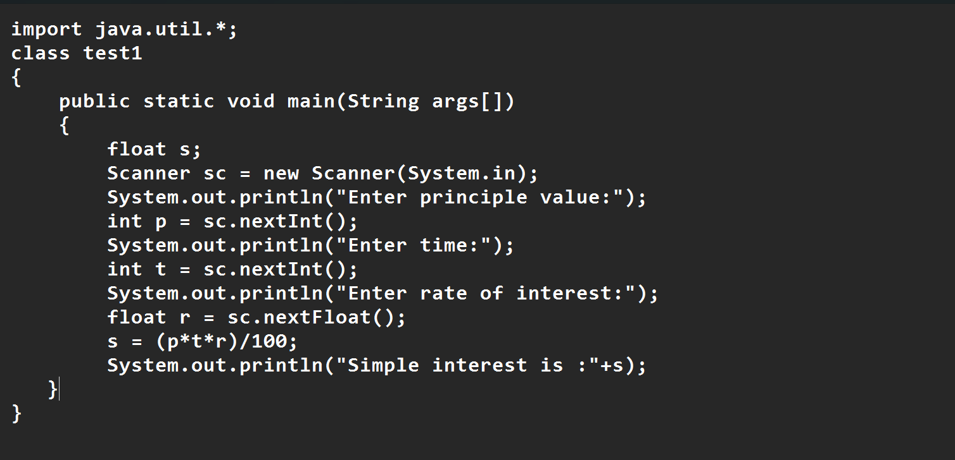

**Output**

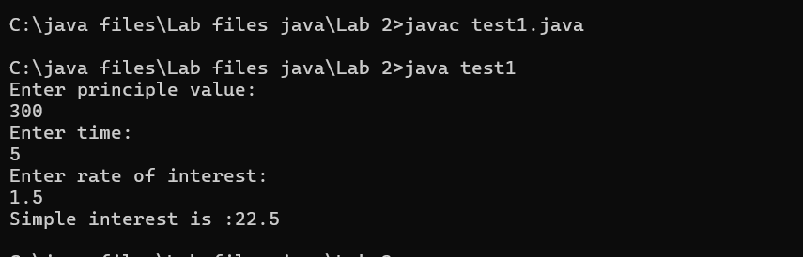

|  |  |  |  |
| --- | --- | --- | --- |
| **S.No** | **Error type** | **Reason for error** | **rectification** |
| **1** | **Runtime error** | **Incorrect path** | **Copied correct path** |
| **2** | **Syntax error** | **{ missing** | **{ added** |
| **3** | **Logical error** | **Wrong formula** | **Formula rectified** |

**2 )AIM:**

**.Write a simple program to calculate factorial of a number and read the**

**input from user**

**code:**

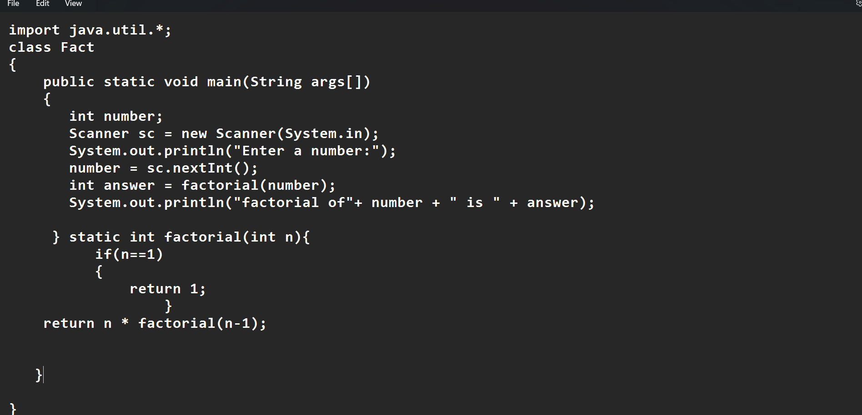

**Output:**

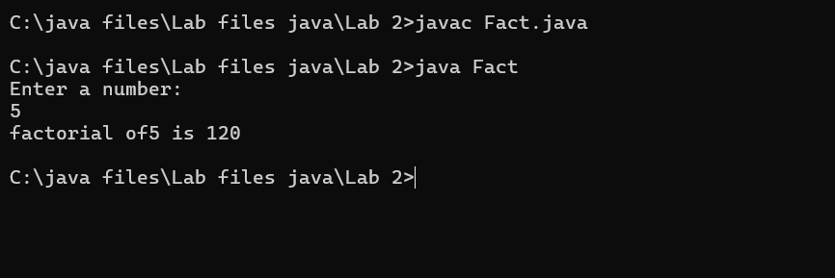

|  |  |  |  |
| --- | --- | --- | --- |
| **S.No** | **Error type** | **Reason for error** | **Rectification** |
| **1** | **Undeclared variable error** | **Missing variable** | **Variable declared** |
| **2** | **Missing import statement** | **Not importing packages** | **Packages imported** |
| **3** | **Logical error** | **Wrong formula** | **Formula rectified** |

**3) AIM:**

**Write a program to to calculate the fibonacii sequence and take the input from user**

**Code:**

**import java.util.*;**

**class fibo**

**{**

**public static void main(String args[])**

**{**

**Scanner sc = new Scanner(System.in);**

**int num;**

**int f3;**

**int f1 = 0;**

**int f2 = 1;**

**int i = 2;**

**System.out.print("Enter a number:");**

**num = sc.nextInt();**

**System.out.println(f1);**

**System.out.println(f2);**

**while(i<num)**

**{**

**f3 = f1+f2;**

**f1 = f2;**

**f2 = f3;**

**System.out.println(f3);**

**i = i+1;**

**}**

**}**

**}**

**Output:**

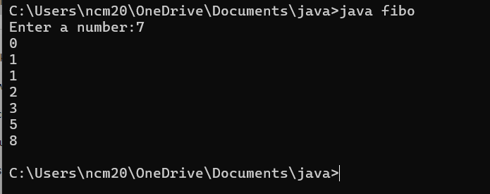

|  |  |  |  |
| --- | --- | --- | --- |
| **S.No** | **Error type** | **Reason for error** | **Rectification** |
| **1** | **Logical error** | **Incorrect formula** | **Formula rectified** |
| **2** | **Run-time error** | **Incorrect path** | **Added correct path** |
| **3** |  |  |  |

**5) AIM**

**Write a java program to convert temperature from Fahrenheit to celsius**

**Code:**

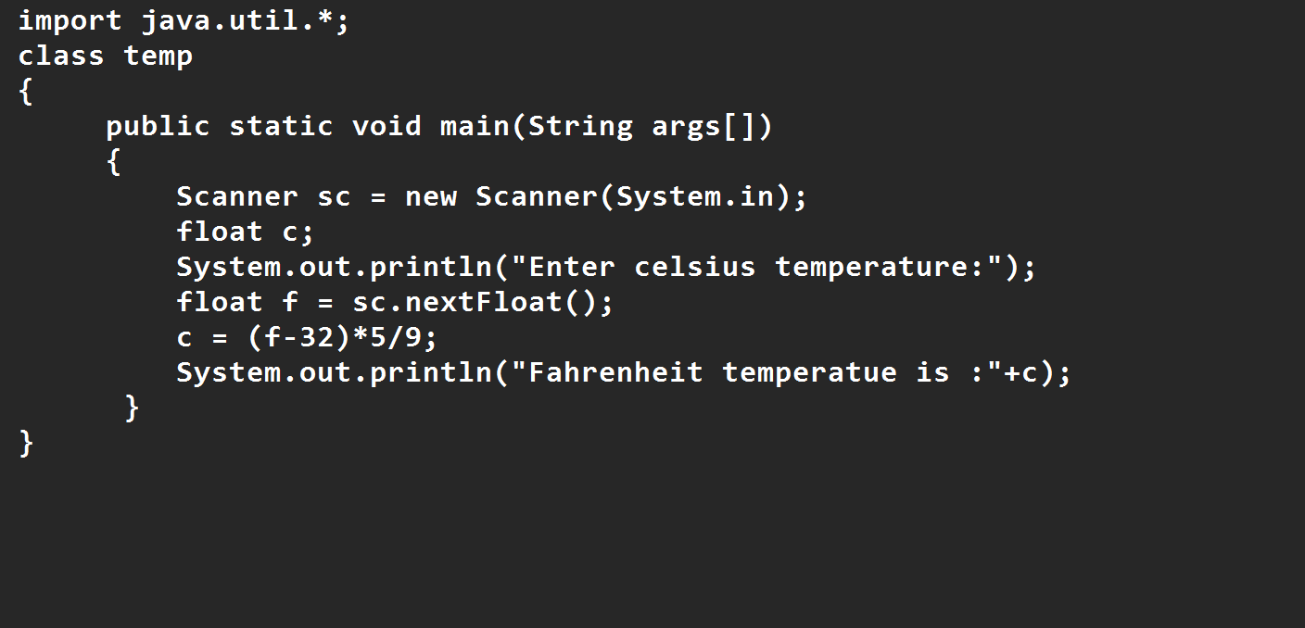

**Output:**

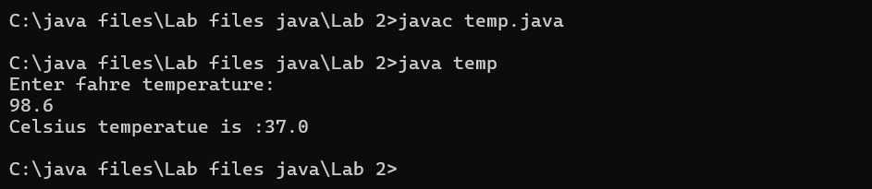

|  |  |  |  |
| --- | --- | --- | --- |
| **S.No** | **Error type** | **Reason for error** | **rectification** |
| **1** | **Syntax error** | **Missing ”** | **“ is added** |
| **2** | **Missing import error** | **Util package missing** | **Util package added** |
| **3** |  |  |  |

**AIM:**

**Write a java program to convert temperature from Celsius to Fahrenheit**

**Code**

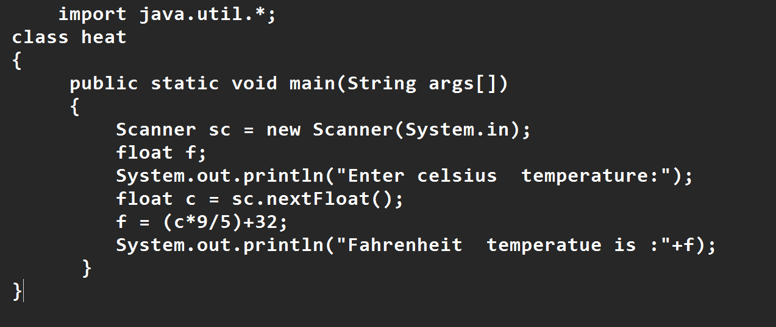

**Output:**

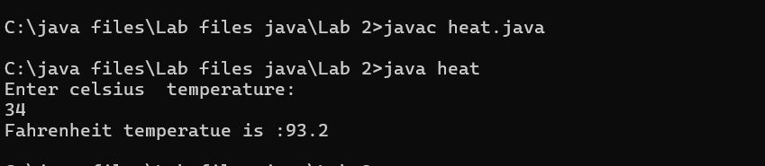

|  |  |  |  |
| --- | --- | --- | --- |
| **S.No** | **Error type** | **Reason for error** | **Rectification** |
| **1** | **Runtime error** | **Incorrect path selection** | **Correct path added** |
| **2** | **Logical error** | **Incorrect logic** | **Correct logic** |
| **3** |  |  |  |

**6) AIM:**

**Write a simple program to find the area of rectangle:**

**Code:**

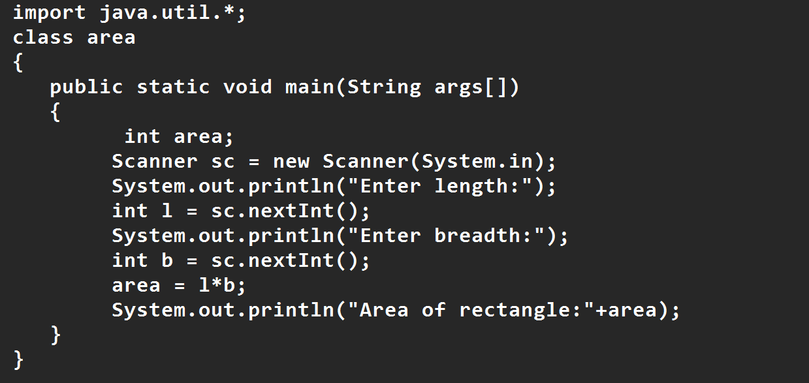

**Output:**

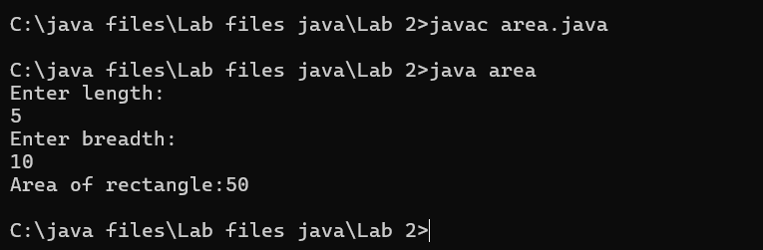

|  |  |  |  |
| --- | --- | --- | --- |
| **S.No** | **Error type** | **Reason for error** | **Rectification** |
| **1** | **Syntax error** | **Semi colon missing** | **Semi colon added** |
| **2** | **Missing import error** | **Import package missing** | **Import package added** |
| **3** |  |  |  |

7)AIM:

**Write a program to find the area of triangle by using heron’s formula take the input from the user**

**Code:**

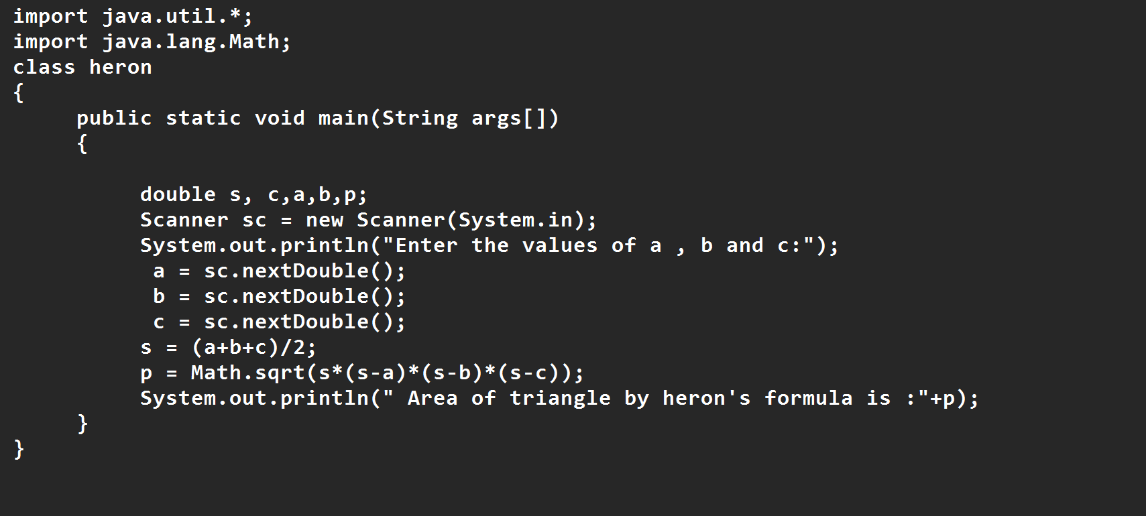

**OUTPUT:**

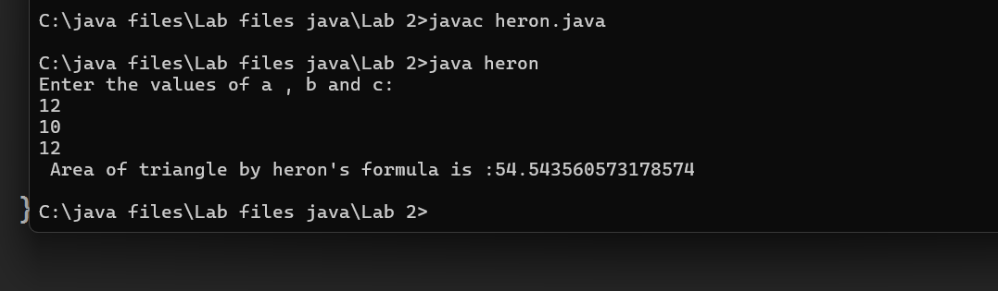

|  |  |  |  |
| --- | --- | --- | --- |
| **S.No** | **Error type** | **Reason for error** | **Rectification** |
| **1** | **Logical error** | **Incorrect formula** | **Formula rectified** |
| **2** | **Name error** | **Undeclared variable** | **Variable declared** |
|  |  |  |  |

**WEEK 3**

**Aim:**

**To create java program with following instructions**

**1.Create a class with name car**

**2. Create four attributes named car_color ,Car_brand,fuel_type,mileage**

**3. Create three methods named start(), stop(). Service()**

**4. Create three objects named car1,car2 and car3**

**Code:**

**import java.util.*;**

**class car**

**{**

**public String Car_color;**

**public String Car_brand;**

**public String fuel_type;**

**public int mileage;**

**public void start()**

**{**

**System.out.println("Car Started:");**

**System.out.println("Car color is :"+Car_color);**

**System.out.println("Car Brand is:"+Car_brand);**

**System.out.println("Car fuel type is:"+fuel_type);**

**System.out.println("Car mileage is:"+mileage);**

**}**

**public void service()**

**{**

**System.out.println("Car Started:");**

**System.out.println("Car color is :"+Car_color);**

**System.out.println("Car Brand is:"+Car_brand);**

**System.out.println("Car fuel type is:"+fuel_type);**

**System.out.println("Car mileage is:"+mileage);**

**}**

**public void stop()**

**{**

**System.out.println("Car Started:");**

**System.out.println("Car color is :"+Car_color);**

**System.out.println("Car Brand is:"+Car_brand);**

**System.out.println("Car fuel type is:"+fuel_type);**

**System.out.println("Car mileage is:"+mileage);**

**}**

**public static void main(String args[])**

**{ System.out.println("\n ncm\n\n");**

**car car1 = new car();**

**car1.Car_color = "Blue";**

**car1.Car_brand = "BMW";**

**car1.fuel_type = "Deisel";**

**car1.mileage = 10;**

**car1.start();**

**car car2 = new car();**

**car2.Car_color = "Red";**

**car2.Car_brand = "Tesla";**

**car2.fuel_type = "EV";**

**car2.mileage = 300;**

**car2.stop();**

**car car3 = new car();**

**car3.Car_color = "Yellow";**

**car3.Car_brand = "MAHINDRA";**

**car3.fuel_type = "Petrol";**

**car3.mileage = 20;**

**car3.service();**

**}**

**}**

**Output:**

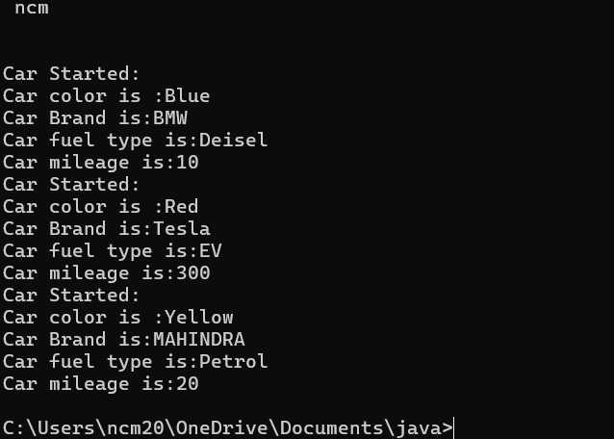

**Class Diagram**

|  |
| --- |
| **Car** |
| **+ car_color: String**  **+ car_brand: String**  **+ fuel_type: String**  **+ mileage: int** |
| **+ Car(): void**  **+ start(): void**  **+ service(): void**  **+ stop(): void** |

**2.AIM:**

**To create a class bankAccount with methods deposit() and withdrawl**

**Code:**

**class BankAccount**

**{**

**private double balance;**

**public BankAccount(double initialBalance)**

**{**

**if(initialBalance > 0)**

**{**

**this.balance = initialBalance;**

**}**

**else**

**{**

**this.balance = 0;**

**}**

**}**

**public void deposit(double amount)**

**{**

**if(amount>0)**

**{**

**balance = balance+amount;**

**System.out.println("Deposited $:"+amount);**

**}**

**else**

**{**

**System.out.println("Deposited amount must be positive");**

**}**

**}**

**public double getBalance()**

**{**

**return balance;**

**}**

**}**

**public class Main1**

**{**

**public static void main(String args[])**

**{**

**BankAccount account = new BankAccount(1000);**

**account.deposit(500);**

**System.out.println("Current Balance is:"+account.getBalance());**

**}**

**}**

**Output:**

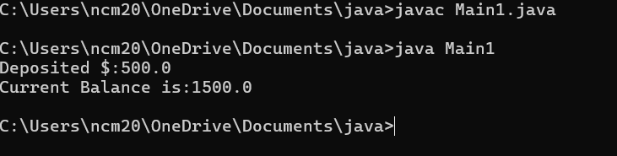

**ERRORS:**

|  |  |  |
| --- | --- | --- |
| **Sno.** | **Error message** | **Error rectification** |
| 1. | error: ';' expected  cust1.withdraw(3050) | Add a “;”    cust1.withdraw(3050); |
| 2. | error: cannot find  symbol  thisCurrBal=CurrBal; | Add a “.”    this.CurrBal=CurrBal; |

WEEK-4

**1.AIM:**

**WRITE A JAVA PROGRAM WITH CLASS NAMED “Book”. THE CLASS SHOUKD CONTAIN VARIOUS ATTRIBUTES SUCH AS TITLE, AUTHOR, YEAR OF**

**PUBLICATION. IT SHOULD ALSO CONTAIN A CONSTRUCTOR WITH**

**PARAMETERS WHICH INITIALIZES TITLE, AUTHOR, YEAR OF PUBLICATION**

**AND CREATE A METHOD WHICH DISPLAYS THE DETAILS OF 2 BOOKS.**

**PROGRAM:**

**public class Book {**

**public String title;**

**public String author;**

**public int year;**

**Book(String title, String author, int year) {**

**this.title = title;**

**this.author = author;**

**this.year = year;**

**}**

**public void displayDetails() {**

**System.out.println("Title: " +title);**

**System.out.println("Author: " +author);**

**System.out.println("Year of Publication" +year);**

**}**

**public static void main(String[] args) {**

**Book b1 = new Book("Math", "Ramanujan", 1950);**

**Book b2 = new Book("Physics", "CV Raman", 1960);**

**b1.displayDetails();**

**b2.displayDetails();**

**}**

**}**

**Output:**

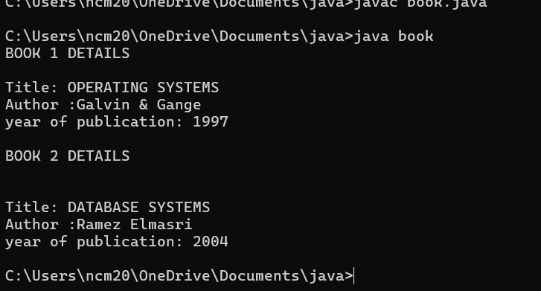

|  |
| --- |
| **Book** |
| **-title: String**  **-author: String**  **-year: int** |
| **+ Book(title: String, author:String, year: int) + displayDetails(): void** |

**2.AIM:**

**WRITE A JAVA PROGRAM WITH CLASS NAMED “MyClass” WITH STATIC VARIABLE COUNT OF INT TYPE INTIALIZE IT TO ZERO AND CONSTANT “Pi” OF TYPE DOUBLE INITIALIZED TO “3.14” AS ATTRIBUTES OF THAT CLASS. NOW DEFINE A CONSTRUCTOR FOR “MyClass”, THAT INCREMENTS THE COUNT VARIABLE EACH TIME AN OBJECT OF “MyClass” IS CREATED. FINALLY, PRINT**

**FINAL VALUES OF ‘COUNT’ AND ‘PI’ VARIABLES AND CREATE 3 OBJECTS.**

**PROGRAM:**

**public class MyClass {**

**static int count = 0;**

**static final double pi = 3.14;**

**MyClass() {**

**count++;**

**}**

**public static void main(String[] args) {**

**MyClass obj1 = new MyClass();**

**MyClass obj2 = new MyClass();**

**MyClass obj3 = new MyClass();**

**System.out.println("Count: " +count);**

**System.out.println("Pi: " +pi);**

**}**

**}**

**OUTPUT:**

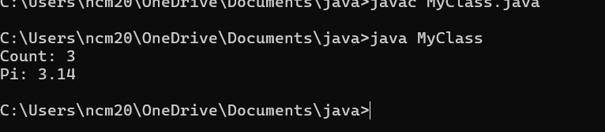

**CLASS DIAGRAM:**

|  |
| --- |
| MyClass |
| -count: int (static)  -pi: double (static, final) |
| +MyClass()  +main(args: String[]):void |

**WEEK-5**

**1)Aim :** create a calculator using the operations including addition, subtraction, multiplication and division using multilevel inheritance and display the desired output .

**Program :**

public class calculator {

    int a = 18;

    int b = 1;

void addition(){

    System.out.println("Addition is :" + (a+b));

}

}

class multi1 extends calculator{

    void subtraction(){

        System.out.println("Subtraction is :" + (a-b));

    }

}

class multi2 extends calculator{

    void multiplication(){

        System.out.println("Multiplication is :" + (a*b));

    }

}

class multi3 extends calculator{

    void division(){

        System.out.println("Division is :" + (a/b));

    }

}

class multipleinheritance {

    public static void main(String[] args) {

        multi1 m1 = new multi1();

        multi2 m2 = new multi2();

        multi3 m3 = new multi3();

        m1.addition();

        System.out.println("    ");

        m1.subtraction();

        System.out.println("    ");

        m2.multiplication();

        System.out.println("    ");

        m3.division();

}

}

**OUTPUT :**

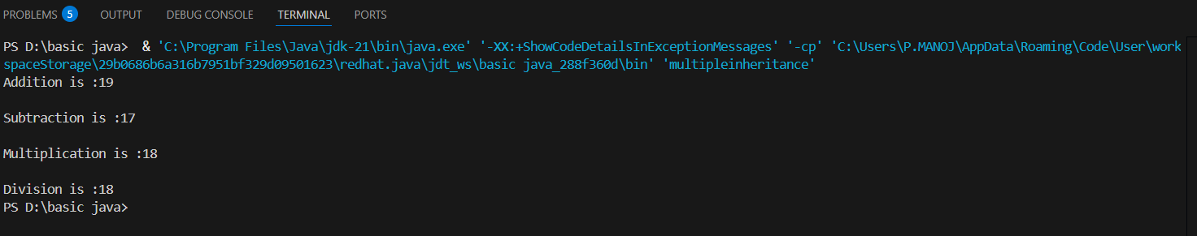

**ERROR :**

|  |  |  |  |
| --- | --- | --- | --- |
| **S.No** | **Error type** | **Reason for error** | **Rectification** |
| 1 | syntax error | String forgot in main function | String is added |
| 2 | Logical error | Incorrect logic | Correct logic |

**2)** **Aim:** A vehicle rental company wants to develop a system that maintains information about different types of vehicles available for rent. The company rents out cars and bikes and they need a program to store details about each variable such as brand and speed.

• Cars should have an additional property: numbers of doors, seating capacity.

• Bikes should have a property indicating whether they have gears or not.

• The system should also include a function to display details about each vehicle & indicates when a vehicle is starting.

• Every class should have constructor.

1. Which OOP concept is used in the above program? Explain why it is useful in this scenario.

2. If the company decides to add a new type of vehicle: Truck, how would you modify the program?

• Truck should include an additional property capacity(in tons)

• Create a ShowTruckDetails() method to display the truck’s capacity.

• Write a constructor for Truck that initializes all properties.

3)Aim: Implement the truck class and update the main method to create a truck object & also create an object for car & bike sub classed. Finally display its details

**Program :**

class Vehicle{

    String brand;

    int speed;

    Vehicle(String brand,int speed){

        this.brand=brand;

        this.speed=speed;

    }

    void Details(){

        System.out.println("Brand:"+brand);

        System.out.println("Speed:"+speed);

    }

}

class CARS extends Vehicle{

    int doors;

    int capacity;

    public CARS(String brand,int speed,int doors,int capacity){

        super(brand, speed);

        this.doors=doors;

        this.capacity=capacity;

    }

    void cardetails(){

        System.out.println("Number of doors:"+doors);

        System.out.println("Capacity:"+capacity);

    }

}

class Bikes extends Vehicle{

    Boolean gears;

    Bikes(String brand,int speed,Boolean gears){

        super(brand, speed);

        this.gears=gears;

    }

    void bikedetails(){

        if (gears==true)

        System.out.println("This bike has gears.");

        else

        System.out.println("This bike does not have gear system.");

    }

}

class Trucks extends Vehicle{

    int tons;

    Trucks(String brand,int speed,int tons){

        super(brand, speed);

        this.tons=tons;

    }

    void truckdetails(){

        System.out.println("The capacity of truck is: "+tons);

    }

}

class Rent{

    public static void main(String[] args){

        CARS c=new CARS("Tayota",120,5,5);

        c.cardetails();

        c.Details();

        Bikes b=new Bikes("KTM",80,true);

        b.bikedetails();

        b.Details();

        Trucks t=new Trucks("TATA",100,1);

        t.truckdetails();

        t.Details();

    }

}

**OUTPUT :**

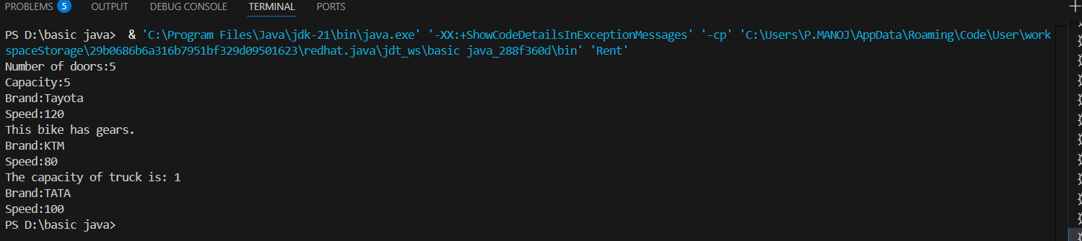

**ERROR :**

|  |  |  |  |
| --- | --- | --- | --- |
| **S.No** | **Error type** | **Reason for error** | **Rectification** |
| 1 | syntax error | String forgot in main function | String is added |
| 2 | Logical error | Incorrect logic | Correct logic |

**WEEK – 6**

**1)Aim : Write a Java program to create a Vehicle class with method displayInfo().Override this method in the Car subclass to provide specific information about a car.**

**Program :**

class vehicle{

    String company;

    String model;

    String fuel;

    int capacity;

    void displayInfo(String company,String model,String fuel,int capacity){

        System.out.println("The details of vehicle: ");

        this.company=company;

        this.model=model;

        this.fuel=fuel;

        this.capacity=capacity;

    }

}

class car extends vehicle{

    void displayInfo(String company,String model,String fuel,int capacity){

        System.out.println("Company: "+company);

        System.out.println("Model: "+model);

        System.out.println("Fuel: "+fuel);

        System.out.println("Capacity: "+capacity);

    }

}

class poly1{

    public static void main(String[] args){

        car car1=new car();

        car1.displayInfo("Audi","Model","Diesel",4);

    }

}

**OUTPUT :**

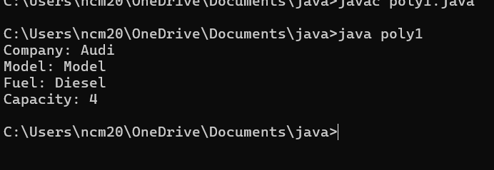

**ERRORS :**

|  |  |  |  |
| --- | --- | --- | --- |
| **S.No** | **Error type** | **Reason for error** | **Rectification** |
| 1 | Syntax error | [] is missed | [] is added |
| 2 | Logical error | Incorrect logic | Correct logic |

**2) Aim :** A college is developing an automated admission system that verifies students eligibility for undergraduate (UG) and postgraduate (PG) programs. Each program has different eligibility criteria based on the students' percentage in their previous qualifications.

(i)UG admissions require a minimum of 60%.

(ii)PG admissions require a minimum of 70%

**Program :**

class College{

    String name;

    int percentage;

    void geteligibility(String name,int percentage){

        this.name=name;

        this.percentage=percentage;

    }

}

class UG extends College{

    void geteligibility(String name,int percentage){

        if (percentage>=60){

            System.out.println(name+" is eligible");

        }

        else{

            System.out.println(name+" is not eligible");

        }

    }

}

class PG extends College{

    void geteligibility(String name,int percentage){

        if (percentage>=70){

            System.out.println(name+" is eligible");

        }

        else{

            System.out.println(name+" is not eligible");

        }

    }

}

class poly2{

    public static void main(String[] args){

        UG ug=new UG();

        ug.geteligibility("Person-1",40);

        PG pg=new PG();

        pg.geteligibility("Person-2",80);

    }

}

**OUPUT :**

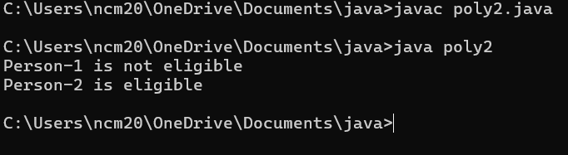

**ERROR :**

|  |  |  |  |
| --- | --- | --- | --- |
| **S.No** | **Error type** | **Reason for error** | **Rectification** |
| 1 | syntax error | String forgot in main function | String is added |
| 2 | Logical error | Incorrect logic | Correct logic |

**3) Aim :** Create a Calculator class with overloaded methods to perform addition:

(i) Add two integers.

(ii) Add two doubles.

(iii) Add three integers.

**Program :**

class Calcee{

    public int add(int a,int b){

        return a+b;

    }

    public double add(double a,double b){

        return a+b;

    }

    public int add(int a,int b,int c){

        return a+b+c;

    }

}

class poly3{

    public static void main(String[] args){

        Calcee C1=new Calcee();

        System.out.println("Sum of 2 and 5 is: "+C1.add(2,5));

        System.out.println("Sum of 3.2 and 6.5 is: "+C1.add(3.2,6.5));

        System.out.println("Sum of 2,5 and 3 is: "+C1.add(2,5,3));

    }

}

**OUTPUT :**

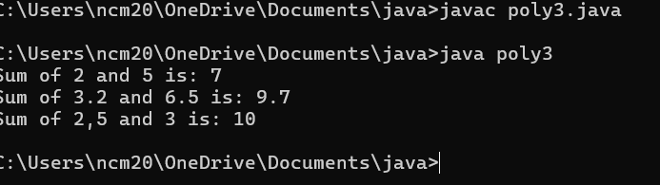

**ERROR :**

|  |  |  |  |
| --- | --- | --- | --- |
| **S.No** | **Error type** | **Reason for error** | **Rectification** |
| **1** | **syntax error** | **String forgot in main function** | **String is added** |
| **2** | **Logical error** | **Incorrect logic** | **Correct logic** |

**4)Aim : Create a Shape class with a method calculateArea() that is overloaded for different shapes (e.g., square, rectangle). Then, create a subclass Circle that overrides the calculateArea() method for a circle.**

**Program :**

**class Shape { // class shape**

**void calculateArea( int a) { // method 1**

**System.out.println("The area of Square is :" + (a*a) );**

**}**

**void calculateArea(int a , int b) { // method 2**

**System.out.println("The area of rectangle is :" + (a*b));**

**}**

**}**

**class circle extends Shape { // inheritance class**

**void calculateArea(double a){ // method overloading**

**System.out.println("The area of circle is :" + (3.14*a*a));**

**} }**

**class main { // main program**

**public static void main(String[] args) {**

**// creating objects for class**

**Shape s = new Shape();**

**circle c = new circle();**

**// calling methods**

**s.calculateArea(4);**

**System.out.println("    ");**

**s.calculateArea(4, 5);**

**System.out.println("    ");**

**c.calculateArea(2);**

**}**

**}**

**OUTPUT :**

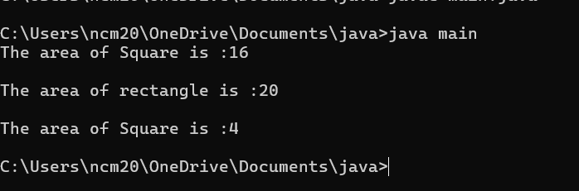

**ERRORS :**

|  |  |  |  |
| --- | --- | --- | --- |
| **S.No** | **Error type** | **Reason for error** | **Rectification** |
| **1** | **Syntax error** | **; is missed** | **; is added** |
| **2** | **Logical error** | **Incorrect logic** | **Correct logic** |